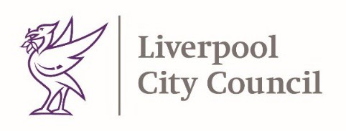
Dear Parents / Carers,

In recent weeks, we have seen a rapid rise in Covid-19 cases in Liverpool. Currently Liverpool has rates of 158/100,000 and is on an upward trajectory. The dominant strain of virus in the UK is called the Delta variant and we have seen a steep rise in COVID-19 cases locally. Evidence suggests the Delta variant spreads more easily than previous strains.

As a result, we are requesting that additional measures are brought into schools to slow down the spread of the virus. These controls may cause some disruption to end of year plans that normally take place. Activities such as transition, assemblies, proms and performances may need to be modified and alternative arrangements made. Educational visits may also be impacted by these additional measures.
Schools will communicate with parents directly if any of their plans are impacted.

Face Coverings

On the 21st ofJune 2021, we are requesting staff and pupils in Year 7 and above to wear face coverings indoors whilst in school, including in classrooms where social distancing cannot be maintained, with the exception of certain lessons such as PE. This is an additional measure to support schools to manage the increased risk of school-based transmission due to increasing cases and is fully supported by central government.

The purpose of wearing a face covering is to minimise the risk of transmitting the virus to other people if you are infectious but don’t have symptoms. We know that up to 30% of people with COVID-19 don’t experience symptoms, and everyone who has the virus will be infectious in the two days before their symptoms start, so wearing face coverings is one of a range of infection prevention and control measures that have been introduced in schools to protect pupils and staff.

Exemptions for wearing face coverings are still in place and further information about exemptions can be found here.
Any pupil who has one of the conditions on the exemption list will not be expected to wear a face covering whilst in school. Anyone communicating to someone who relies on lip reading will also be exempt from wearing a face covering.

We also continue to ask that parents and carers to wear face coverings when dropping off and picking up children from school.

As always, we thank you for your continued support.

Yours faithfully

Matt Ashton Steve Reddy
Director of Public Health, Liverpool Director of Children’s Services, Liverpool

